DESIGNER SHOW HOUSE

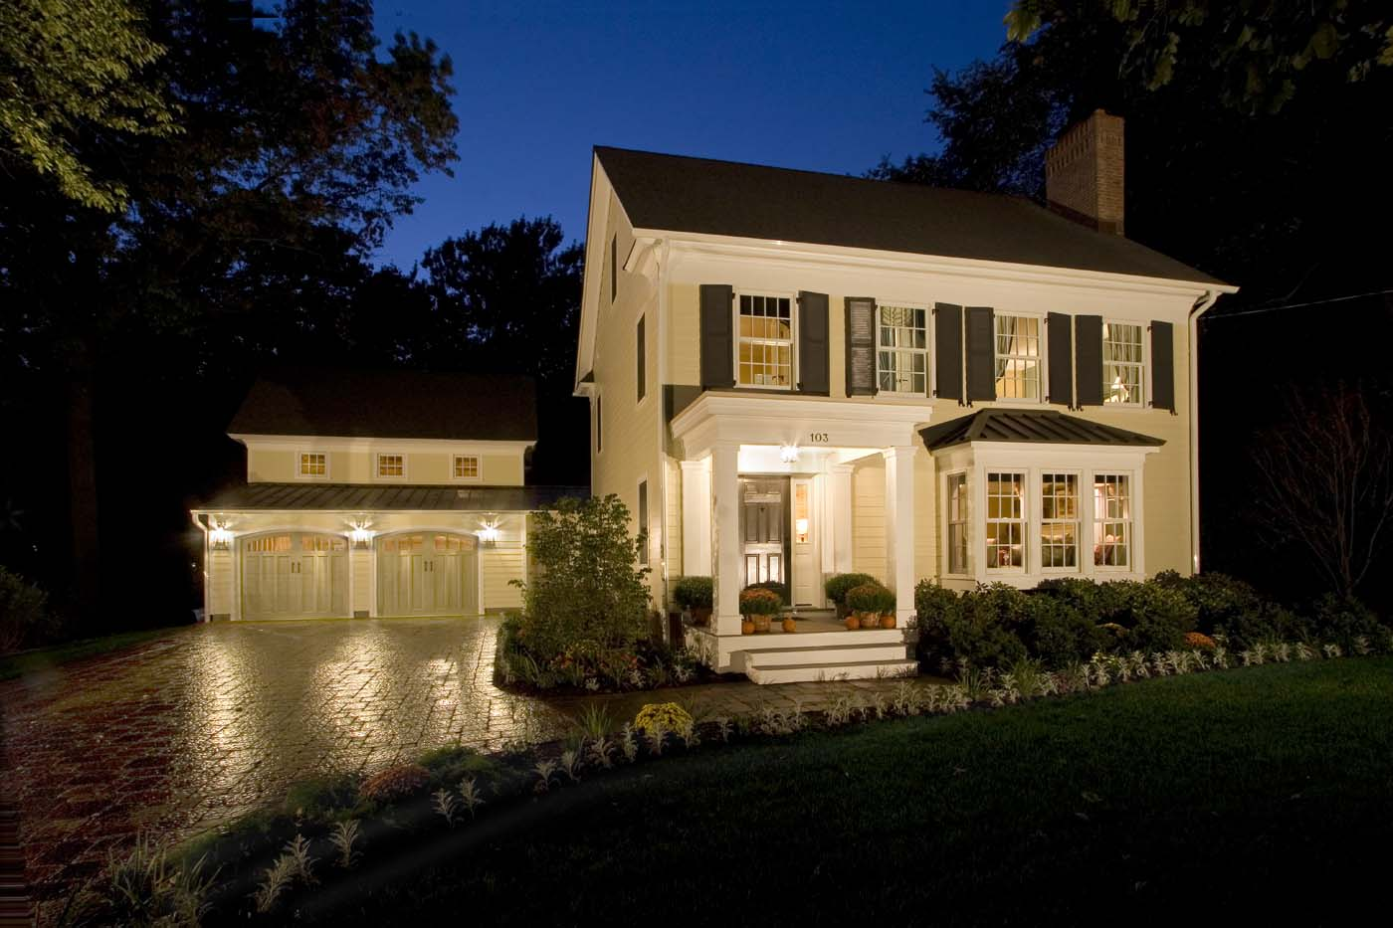

KAISER BUILDING Co.
P. O. Box 537 • Cranbury, NJ 08512
609•860•1900

